National Football Museum
Risk Assessment – Museum Education Sessions
Introduction
This risk assessment has been created to evaluate the risk to school/education group visitors whilst visiting the museum
The risk assessment evaluates our current risks, precautions and procedures and where required recommends the introduction of additional reasonable controls to further minimise risk to acceptable levels.

Scoring:
The evaluation in this document is based on a 25 square grid with likelihood (L) and consequence (C) rated from 1-5 and then multiplied to give a risk level (R). This is the standard procedure as recommended by The Institution of Occupational Safety and Health (IOSH)
A score is calculated given the existing precautions and then recalculated if the additional precautions were to be actioned.
For the purposes of this document the word “staff” relates to paid NFM staff, NFM volunteers, contractors & work-related visitor
Likelihood
- Very unlikely – 1 in a million chance of hazardous event
- Unlikely – 1 in 100,000 chance of hazardous event
- Fairly likely – 1 in 10,000 chance of hazardous event
- Likely – 1 in 1000 chance of the hazardous event
- Very likely – 1 in 100 chance of hazardous event

Consequence
- Insignificant – no injury
- Minor – minor injuries needing first aid
- Moderate – up to 3 days absence
- Major – more than 7 days absence
- Catastrophic - Death

Risk Level (R) categories
17-25 Unacceptable – action required urgently
10-16 Tolerable – action required within timescales
5-9 Adequate – Look to improve
1-4 Acceptable – no further action but ensure controls are maintained
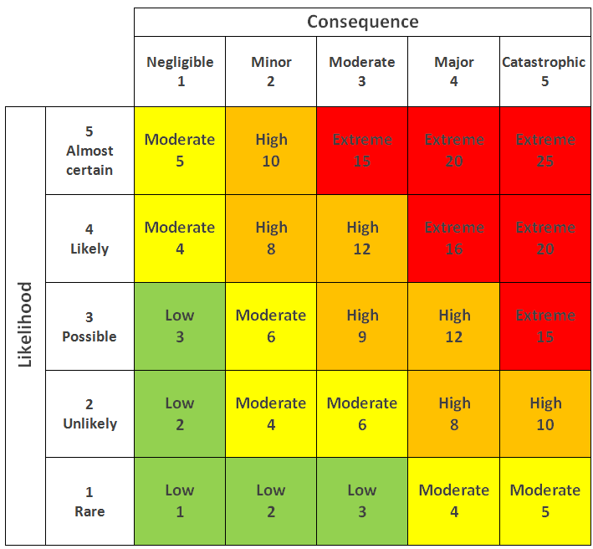
Company:  National Football Museum | Department:  Communities | Site Name:  Urbis Building / National Football Museum

Work Activity | Hazard & consequence | People / objects affected | L | C | R | Current controls | Additional controls required | L | C | R
Visit by education group | Fire, serious injury or death | visitors | 2 | 5 | 10 | Fire risk assessment  Designed escape routes and general exit provision  Fire alarm system & testing  Emergency lighting  Fire extinguishers  Trained staff evacuation  No smoking  Hot works permits for contractors  Gas appliance servicing  Housekeeping  Electrical system testing  Drills  Emergency lighting  Catering Ventilation cleaning  Staff training in use of extinguishers. | Complete scheduled PAT testing | 1 | 5 | 5
Visit by education group | Poor lighting, trip, minor injury | visitors | 2 | 2 | 4 | Continuous programme of bulb replacement  Riskier areas are well lit (e.g. stairs) |  | 2 | 2 | 4
Visit by education group | Rotating door, minor injury | visitors | 3 | 3 | 9 | Stickers on glass panels instructing how to use | Most Schools entry through the accessible entryway or café entrance, not rotating doors. | 1 | 3 | 3
Visit by education group | Automatic doors, minor injury | visitors | 2 | 3 | 6 | Marked as to which way they open  Glass panels have stickers  Faults are monitored and resolved by ASM  Door on discovery zone on manual setting |  | 2 | 3 | 6
Visit by education group | Slips trips and falls, minor injury: escalator | visitors | 1 | 4 | 4 | Moving handrail  Marked edges to start and on the steps  Warning signs at entrance to area  Short escalator  Maintained, serviced and insured as per requirements  Stepped area lit |  | 1 | 4 | 4
Visit by education group | Slips trips and falls, minor injury:  staircases | visitors | 1 | 4 | 4 | Maintained floors  Handrails  Marked differentiating edges  All staircases have short runs of steps with flat areas reducing potential fall distance |  | 1 | 4 | 4
Visit by education group | Slips trips and falls, minor injury:  General areas | visitors | 2 | 2 | 4 | Trip hazards removed  Edging strips used for raised items e.g. vents  Monitor astro-turf areas and repair when required  Portable items stored correctly  Use of wet floor signage  Vacuuming and mopping before visitors enter building  Floor plug socket covers monitored  Tiles and ramps replaced |  | 2 | 2 | 4
Visit by education group | Slips trips and falls, minor injury:  external areas | visitors | 2 | 4 | 8 | Pavement and garden areas are generally flat and low, maintained by council  Loose flags have been repaired by MCC  Regularly monitor for gaps in external drainage | Drainage Cover Repair by MCC now complete | 1 | 4 | 4
Visit by education group | Glass display case breakage: cuts, lacerations | visitors | 2 | 4 | 8 | 95% Cases use high standard security glass  All external glass is safety glass  All door glass is safety glass |  | 2 | 4 | 8
Visit by education group | Falls from height:  Balcony edges, escalators, staircases  serious injury or death | visitors | 1 | 5 | 5 | High handrail and glass panels prevent unintended falls  Maximum fall height from balcony is one level  Marked edges on steps  Warning signs at entrance to area  Maintained floors  Marked differentiating edges  All staircases have short runs of steps with flat areas reducing potential fall distance |  | 1 | 5 | 5
Visit by education group | Use of lift: slips, trips , falls, lock in  Hand trapped in door | visitors | 1 | 4 | 4 | Servicing and insurance surveying  Staff awareness – reporting of problems  Auto-sensing doors  Alarm button if stuck |  | 1 | 4 | 4
Visit by education group | Anti-social behaviour: injury | visitors | 2 | 3 | 6 | Security guard 7 days per week  Staff awareness and alarm raising procedures and training  Majority of visitors pay for entry  Liaise with Police and MCC to report behaviour  All children must be accompanied by adult if U18  New CCTV system installed |  | 2 | 3 | 6
Visit by education group | Targeting of children and vulnerable adults by adults | visitors | 1 | 5 | 5 | All children must be accompanied by adult if U16  Safeguarding policy in place  Staff awareness and training |  | 1 | 5 | 5
Visit by education group | Consumption of handling objects and smell jars | visitors | 1 | 2 | 2 | Supervision and reminders from facilitating staff |  | 1 | 2 | 2
Visit by Education Group – craft workshop | Cuts from craft scissors | Visitors | 2 | 1 | 2 | Supervision from group leaders and facilitation staff. |  | 2 | 1 | 2
Appendix for any educational groups & sessions that include activities/risks not listed above.
Date & Activity | Hazard & consequence | People / objects affected | L | C | R | Current controls | Additional controls required | L | C | R

